*Instructions are provided in italics*

Welcome to The Ski Run *(Heading)*

Ski lessons offered: *(Sub-heading)*

private *(bullet)*

must be pre-booked *(sub bullet)*

requires a 10% deposit *(sub bullet)*

group *(bullet)*

beginners *(sub bullet)*

intermediate *(sub bullet)*

advanced *(sub bullet)*

*This table needs to be created and included in the fact sheet.*

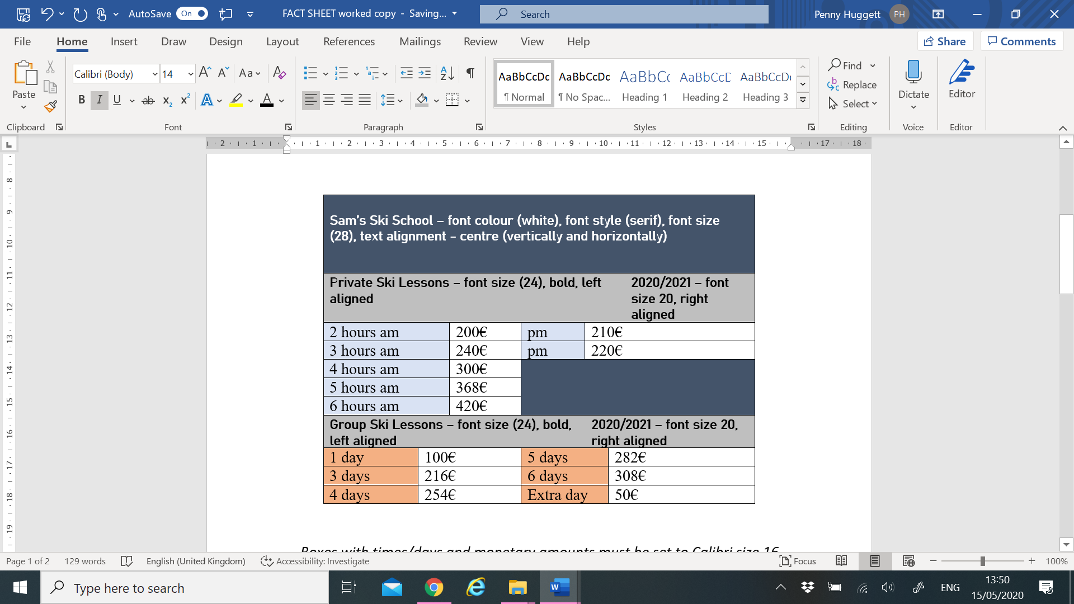

*Boxes with times/days and monetary amounts must be set to Calibri size 16*